**Stage 3**

**RULES:** Practical Shooting Handbook, Latest Edition **COURSE DESIGNER:** Ike Starnes

|  |  |
| --- | --- |
| **START POSITION: See written stage briefings.** | |
| **STAGE PROCEDURE**  Engage targets from within the shooting area. | **SCORING**  **SCORING:** Comstock, 22 rounds, 110 points  **TARGETS:** 11 cardboard targets  **SCORED HITS:** 2 Best hits per carboard will be scored  **START-STOP:**  Audible - Last shot  **PENALTIES:** Mike -10, NS -10, Procedural -10 |

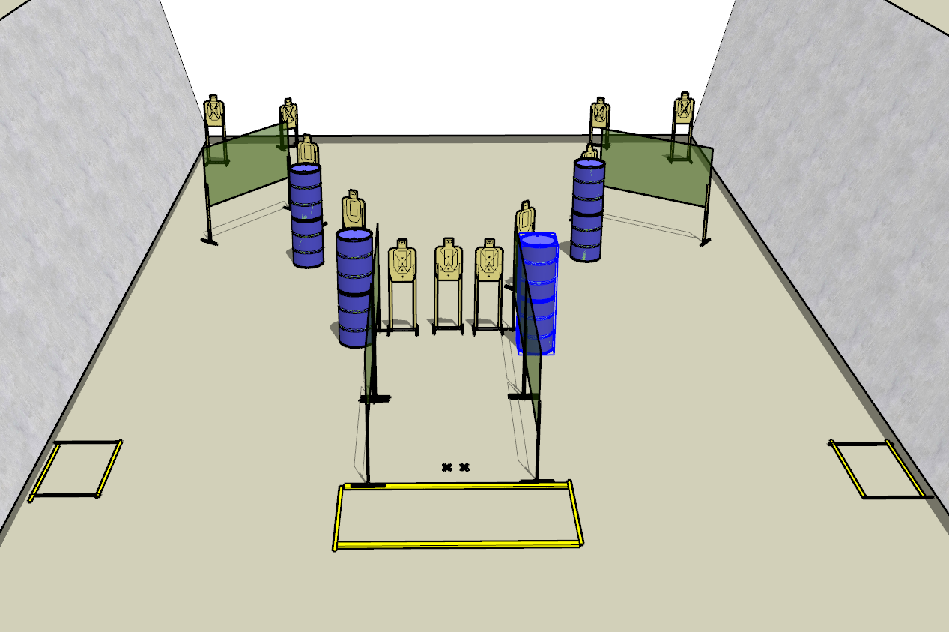

**Written Stage Briefings:**

**Stage 1 –** is a 22-round, 110 point, Comstock Long Course. There are 11 cardboard targets. The best 2 hits per cardboard target will be scored.

**Handgun start position** is standing with both feet on Xs with wrists below belt. The handgun is loaded and holstered.

**PCC start position** is standing with both feet on Xs. PCC is loaded with safety on and buttstock on belt with muzzle pointed downrange.

On the audible start signal, engage targets from within the shooting area.